Figure 1 – Communication of the 2026 Testing Manual Update
Email dated 27 January 2026 announcing the updated Vans Footwear Performance Testing Manual and summarizing revisions to test methods and product performance requirements.
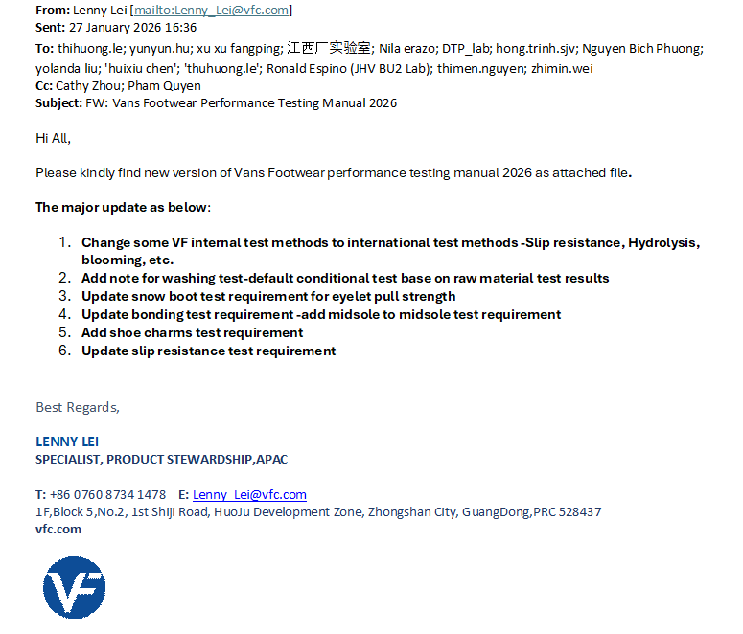
Source: Email from Lenny Lei, Product Stewardship APAC, VFC, 27 January 2026.

Figure 2 – Distribution of the 2026 Testing Manual Update
Email dated 27 January 2026 from Cathy Zhou distributing the updated Vans Footwear Performance Testing Manual to relevant stakeholders and summarizing the principal revisions.
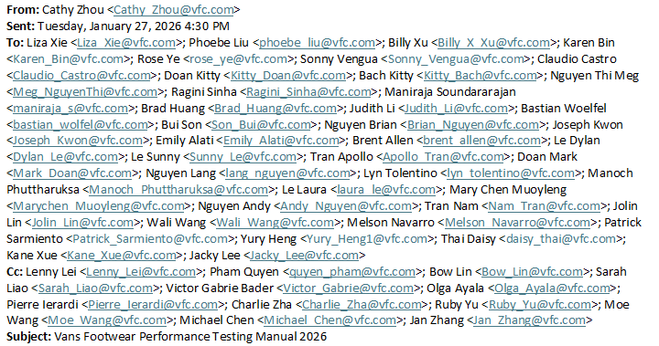
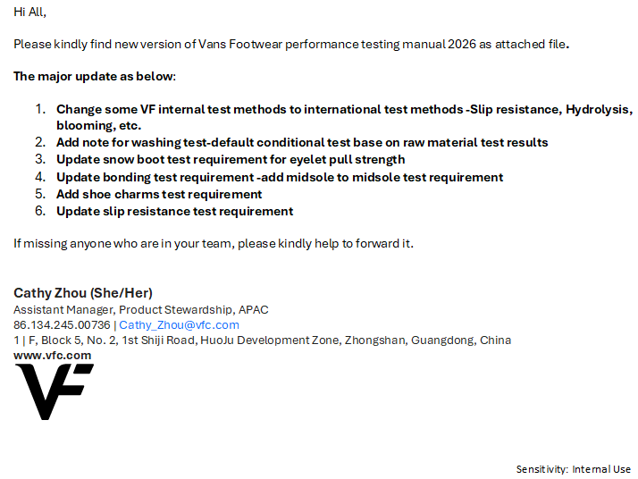
Source: Email from Cathy Zhou, Product Stewardship APAC, VFC, 27 January 2026.

